**Ansible:**

**Ansible** is an open-source automation tool used for configuration management, application deployment, task automation, and IT orchestration. Designed to be simple, agentless, and highly efficient, Ansible allows DevOps teams to automate repetitive tasks, streamline complex workflows, and maintain consistency across infrastructure.

**Agent:** In automation and configuration management, an **agent** is a software component installed on a **managed node** that interacts with the **control node** to receive instructions, perform tasks, and report back status. Tools like Puppet, Chef, and SaltStack typically use agents. However, Ansible is **agentless**, meaning it doesn’t require any additional software on the managed nodes. This makes Ansible simpler to set up and manage compared to agent-based systems.

* **Why Ansible:**

1. **Agentless Architecture:** Ansible does not require any agent on the target machines. It connects via SSH (for Linux) or WinRM (for Windows), making setup and maintenance simpler.
2. **Simple and Human-Readable:** Ansible uses YAML syntax, making it easy to write and understand playbooks (scripts), even for those who are not experienced in scripting or programming.
3. **Efficient and Scalable:** With minimal setup, Ansible scales effectively to manage a large number of servers and supports complex multi-tier deployments.
4. **Idempotent:** Ansible is idempotent, meaning that executing a playbook multiple times on the same system will not result in unexpected changes unless specified, ensuring stability and predictability.
5. **Extensive Community and Ecosystem:** With many pre-built modules, plugins, and playbooks, Ansible has a strong support community and a growing ecosystem, which can significantly reduce the time needed to build automation solutions.

* **How Ansible Works:** Ansible operates on a **‘push’** model, where commands or playbooks are run from a control node that "pushes" configurations and tasks to managed nodes (servers, VMs, etc.). Using SSH or other protocols, it connects to these nodes to execute tasks defined in **playbooks** (YAML files specifying tasks and configurations).
* **Key Components of Ansible:**
* **Playbook:** A **YAML** file that defines a set of tasks to be executed. Each task includes information about what module to use, parameters, and target nodes.
* **Inventory:** A file that specifies the list of hosts (nodes) managed by Ansible.
* **Modules:** Ansible includes modules for different types of tasks, like file management, service management, user management, and package installation.
* **Roles:** A way to organize playbooks and tasks into reusable components.
* **Benefits of Ansible:**
* **Consistency across Environments:** By defining each installation step, Ansible ensures the app is deployed identically on each server.
* **Simplicity and Readability:** Using YAML makes the playbook readable, even to non-technical team members.
* **Scalability:** Additional servers can be added to the **inventory** file without modifying the playbook, allowing easy scaling.
* **Importance of Ansible:**

For DevOps engineers, **Ansible’s** ability to automate configuration and management tasks plays a crucial role in maintaining agile, efficient, and stable infrastructure. It enables faster deployments, reduces human error, and facilitates a streamlined approach to system provisioning and maintenance.

Ansible is particularly useful in multi-tier applications where different services or applications require consistent setup, such as deploying a web server, setting up a database, or managing Microservices, making it an invaluable tool for modern infrastructure management and automation.

* **Control Node and Managed Nodes:**
* **Control Node:** This is the machine where Ansible is installed and from where you run Ansible commands, playbooks, and modules. The control node sends tasks to managed nodes over SSH (or WinRM for Windows servers) and orchestrates their execution. You can manage multiple nodes from a single control node.
* **Managed Nodes:** These are the remote servers or devices that Ansible manages. Ansible connects to each managed node to perform tasks like configuration management, application deployment, or server setup. Managed nodes don’t require an agent or any Ansible installation.
* **Tasks Ansible Can Perform:**

**Ansible supports a wide range of tasks, including:**

1. **Configuration Management:** Automate server configurations (e.g., setting up **NGINX**, installing software packages).
2. **Application Deployment:** Manage deployments, ensuring consistent versions and setup across servers.
3. **Orchestration:** Coordinate tasks across multiple servers, which can be useful for complex deployments or rolling updates.
4. **Provisioning:** Automate the setup of infrastructure, like creating and configuring virtual machines or cloud resources.
5. **Security Automation:** Ensure security policies, firewall settings, and user permissions are correctly configured across nodes.
6. **Continuous Integration (CI) and Continuous Delivery (CD):** Automate **CI/CD** pipelines, facilitating the integration and deployment of applications.

* **Ansible vs. Shell Scripts:**

**Shell Scripts** are commonly used for automation tasks, but they have limitations compared to Ansible. **Here’s how they compare:**

* **Idempotency:** Ansible ensures Idempotency, meaning tasks can be rerun without unintended consequences (e.g., won’t reinstall software already installed), while shell scripts may not be idempotent unless specifically coded to be so.
* **Readability:** Ansible playbooks use YAML syntax, making them easier to read, understand, and maintain than complex shell scripts.
* **Scalability:** Ansible handles tasks across multiple nodes in parallel, making it easier to manage large-scale infrastructures, whereas shell scripts would require SSH connections to each node.
* **Modularity:** Ansible’s playbooks and roles allow tasks to be organized and reused, providing more flexibility than shell scripts.

**When to Use:**

* **Use Ansible:** For complex, repetitive, multi-node tasks where idempotency and modularity are required. Checking system load and freeing memory on a single server.
* **Use Shell Scripts:** For quick, single-purpose tasks that are not run often or on multiple servers. Deploying an application on multiple servers with consistent configurations, where you may need to check if the package is already installed and then install or configure it as needed.
* **Ansible vs. Python:**

**Python Scripts** are powerful and versatile but, like shell scripts, they can lack some of the advantages Ansible provides for configuration management and orchestration.

**Here’s a comparison:**

* **Simplicity:** Ansible has a vast library of modules for configuration, deployment, and orchestration, making it simpler and faster to automate tasks compared to writing Python scripts from scratch.
* **Abstraction:** Ansible abstracts a lot of complexity (e.g., managing SSH connections and handling error recovery), which you would need to code manually in Python.
* **Error Handling and Idempotency:** Ansible handles idempotency and error recovery out of the box, while Python requires explicit coding for these features.
* **Agentless Operation:** Ansible’s agentless model reduces setup complexity, while Python scripts often require additional libraries on each node.

**When to Use:**

* **Use Ansible:** For infrastructure automation, configuration management, and repetitive tasks across multiple nodes. Writing a custom application that integrates data from multiple APIs with complex transformations.
* **Use Python:** When more control, API integration, flexibility, or custom logic is needed in an application or when automating more complex, programmatic tasks that aren’t easily handled by Ansible modules. Automating the setup of a multi-tier application environment with web servers, database servers, and load balancers, ensuring consistency and reusability across the infrastructure.

**Passwordless Authentication:**

**Passwordless Authentication in Ansible** allows seamless, secure connections to remote nodes without needing to enter a password every time. This setup is essential in automation, as it enables Ansible to execute tasks across multiple servers without manual intervention.

<https://github.com/dibyendubiswas1998/Ansible/blob/main/README.md>

**Key Components of Ansible:**

1. **Inventory:**

* **Definition:** The **Inventory** in Ansible is a file or source that defines and organizes all the managed nodes (hosts) Ansible will work on. It contains details such as IP addresses, hostnames, groups, and variables for each host or group.
* **Purpose and Importance:**
  + **Purpose:** An inventory enables Ansible to know which hosts to target for automation tasks. It allows grouping and configuring hosts in various ways, making it easier to manage different environments (e.g., production, staging, testing).
  + **Importance:** An organized inventory simplifies automation across a complex infrastructure. By defining groups, you can run specific tasks on only relevant hosts (e.g., applying database changes to database servers only).
* **Example:**
* A sample inventory file in **INI format:**

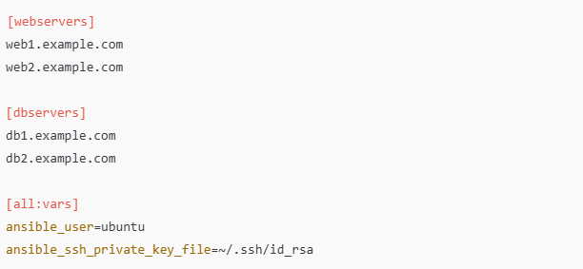

* This inventory has two groups, **webservers** and **dbservers**, with hostnames for each. The **[all: vars]** section sets global variables for all hosts, defining the SSH user and private key for connecting to them.

1. **Module:**

* **Definition:** A **Module** in Ansible is a predefined, standalone script that performs a specific task on the managed node, like installing a package, copying a file, restarting a service, or gathering system information.
* **Purpose and Importance:**
* **Purpose:** Modules provide the building blocks of Ansible automation, allowing you to execute individual tasks on remote hosts.
* **Importance:** Modules streamline repetitive tasks by eliminating the need to write custom scripts for each task. They enable consistent and reliable execution across various systems without custom code, and Ansible has modules for a wide range of tasks (over 1,000 modules).
* **Example:**
* Running an **ad-hoc command** with the **ping** module to check connectivity:



* Here, **-m** **ping** specifies the **ping** module, which checks connectivity with all hosts in the inventory.
* **Commonly Used Modules:**
* **ping** - Verifies connectivity.
* **apt** or **yum** - Manages packages on Debian-based or RHEL-based systems, respectively.
* **copy** - Copies files to remote hosts.
* **service** - Manages services, like starting or stopping.

1. **Playbook:**

* **Definition:** A **Playbook** is a YAML file that contains a series of plays (tasks) defining the actions Ansible should execute on managed nodes. Each play can target specific groups or hosts and specify the order in which tasks are run.
* **Purpose and Importance:**
* **Purpose:** Playbooks define workflows for configuring systems, deploying applications, and performing orchestrated tasks. Each playbook can be as simple or complex as needed, encompassing multiple steps to automate larger processes.
* **Importance:** Playbooks provide reusability, readability, and maintainability for automation scripts. They enable you to encapsulate infrastructure as code, ensuring consistency and reliability across multiple environments. Playbooks are also version-controlled, making it easier to track and audit changes.
* **Example:**
* A simple playbook to install and start **NGINX** on **webservers**:

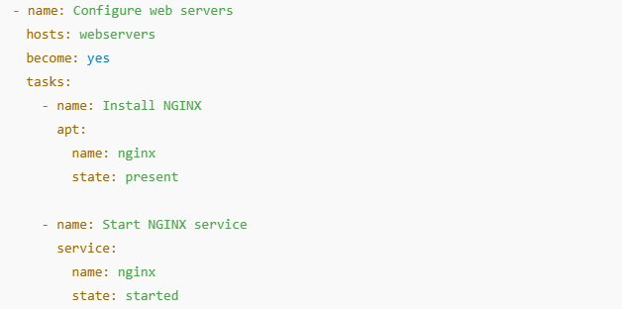

* This playbook does the following:
* Targets the **webservers** group in the inventory.
* Uses the **apt** module to install **NGINX**.
* Uses the **service** module to start **NGINX**.

**Difference between a Text file and YAML file:**

* **Text File:**
* **Usage:** Stores unformatted data, typically readable plain text that may not adhere to a specific structure or syntax.
* **Purpose:** Used for simple information storage (e.g., notes, logs, config files without strict formatting).
* **Characteristics:** Limited readability by software applications as there’s no inherent structure; just a sequence of characters.
* **YAML File:**
* **Usage:** Stores data in a structured, hierarchical format, which is both human-readable and machine-parsable.
* **Purpose:** Often used for configuration files, especially in tools like Ansible, Docker, and Kubernetes, due to its ability to represent complex structures (lists, dictionaries, etc.).
* **Characteristics:** Uses indentation to represent hierarchy, which allows nesting of keys and values, making it readable by both humans and machines.

**Ansible Playbook Structure:**

An Ansible **Playbook** is a YAML file that outlines the tasks and steps Ansible should perform. The structure typically includes **plays**, **modules**, **tasks**, and optionally **collections**, defining automation steps for configuring and managing systems.

* **Basic Playbook Structure:**

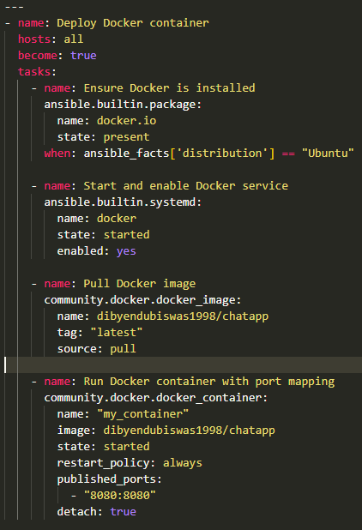

* **Key Components of an Ansible Playbook:**

1. **Play:**

* **Definition:** A play maps a group of hosts (from the inventory) to a set of tasks.
* **Purpose:** Defines what actions to perform on specified hosts, allowing you to organize tasks by host group, roles, or purpose.
* **Example:**



1. **Module:**

* **Definition:** A module is a reusable component or script Ansible uses to perform specific actions, such as managing packages, services, or files.
* **Purpose:** Allows you to perform particular tasks without writing custom scripts.
* **Example:**

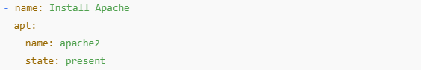

1. **Tasks:**

* **Definition:** Tasks are individual actions within a playbook, executed sequentially on targeted hosts.
* **Purpose:** Specifies the exact actions Ansible should perform on hosts, defining the step-by-step operations for automation.
* **Example:**

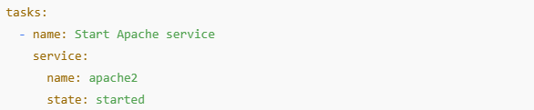

1. **Collection:**
   * **Definition:** Collections are packages of Ansible content, including modules, plugins, and roles, which can be reused across multiple playbooks.
   * **Purpose:** Provides an organized way to manage related Ansible resources and share them, promoting reuse and consistency.
   * **Example:**



**Ansible Roles:**

**Ansible Roles** are a way to organize and structure Ansible tasks, variables, files, and handlers in a standardized folder structure. They enable modularization and reuse, allowing for cleaner, more maintainable playbooks, especially in complex setups.

* **Why Use Ansible Roles:**

Roles make it easy to manage and reuse sets of Ansible configurations across multiple playbooks and environments. By grouping related tasks, variables, and files into a role, it simplifies the development, testing, and debugging of Ansible configurations.

* **Modularity:** Roles allow you to encapsulate configuration code in a way that’s modular and reusable.
* **Organization:** With roles, each part of the configuration is organized into dedicated folders, enhancing readability.
* **Reusability:** Roles enable you to reuse common configurations (like installing a web server) across different playbooks or projects.
* **Scalability:** When managing complex environments, roles help scale automation code in a manageable way.
* **Example of an Ansible Role:**

Suppose you want to configure and deploy an **NGINX web server**. Instead of writing the NGINX tasks directly in a playbook, you can create an NGINX role, which can then be reused across multiple playbooks and projects.

**Using the Role in a Playbook:**

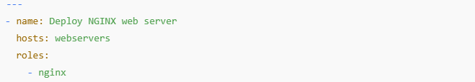

Here, **nginx** is the role that will configure and deploy the NGINX server. It includes all tasks, variables, and files specific to setting up NGINX.

* **Folder Structure of Ansible Role:**

An Ansible role has a standardized directory structure, with each folder serving a specific purpose. Here’s a typical layout:

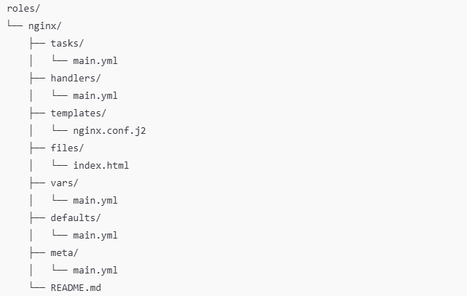

**Explanation of Each Directory:**

1. **task/:** Contains the primary tasks for the role. The main.yml file here includes all tasks related to setting up NGINX.
2. **handlers/:** Defines any notifications or handlers triggered by tasks (e.g., restarting NGINX after configuration changes).
3. **templates/:** Stores Jinja2 templates, which are configuration files with variables. For example, nginx.conf.j2 can define a customizable NGINX configuration.
4. **files/:** Holds static files needed by the role, like index.html for a sample webpage.
5. **vars/:** Contains role-specific variables with higher precedence than defaults.
6. **defaults/:** Stores default variables for the role, which can be overridden if needed.
7. **meta/:** Holds metadata about the role, such as dependencies on other roles, author, license, etc.
8. **README.md/:** (Optional) Provides documentation for the role.

* **Comparing: Roles vs. Playbook**

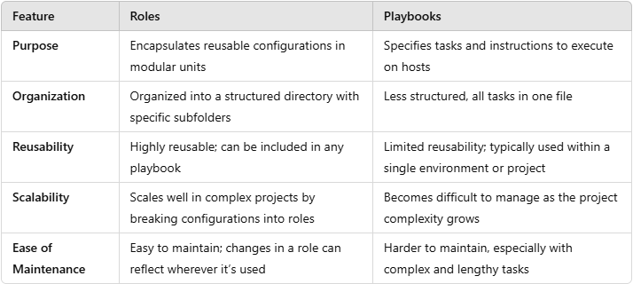

* **Example: Creating an NGINX Role**
* **Step 1: Create the Role Structure**

$ ansible-galaxy role init nginx

This command will generate the standardized folder structure under the nginx/ directory.

* **Step 2: Define Tasks in “tasks/main.yaml”**

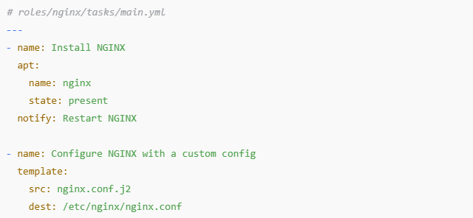

* **Step 3: Define Handlers in “handlers/main.yaml”**

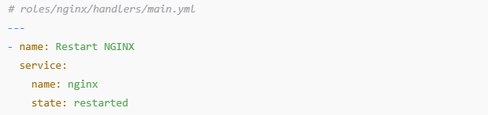

* **Step 4: Customize Configuration in “templates/nginx.conf.j2”**

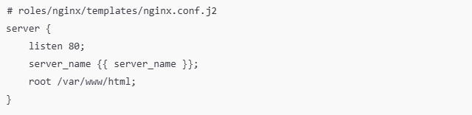

* **Step 5: Use the Role in a Playbook**

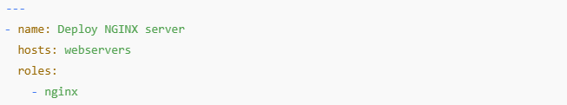

* **Step 6: Execute the Playbook**

$ ansible-playbook –i /path/inventory.ini playbook.yaml

With this setup, the **NGINX** role can be used across different playbooks, making it a powerful tool for scalable, modular, and reusable configurations.

**Ansible Galaxy:**

**Ansible Galaxy** is a community repository for sharing Ansible roles, maintained by Ansible and accessible to all users. It allows developers and system administrators to share reusable Ansible roles that are well-structured, tested, and optimized for various tasks, such as deploying applications, configuring servers, or managing databases.

* **Ansible Galaxy acts as a central hub where you can:**
* **Download** roles created by the community.
* **Upload** your own roles for others to use.
* **Discover** roles specific to particular use cases or technologies (e.g., **nginx**, **mysql**, and **docker**).
* **Purpose and Importance of Ansible Galaxy:**

Ansible Galaxy serves as a powerful resource for the **DevOps** and **IT** community by allowing easy sharing and reuse of Ansible roles. This saves time by providing pre-built solutions and promotes consistency, scalability, and standardization across projects. **Some of the key benefits are:**

* **Standardization:** Provides standardized roles that follow best practices.
* **Reusability:** Allows users to reuse roles for common tasks rather than building them from scratch.
* **Time Efficiency:** Saves time in development by using pre-built roles for common tasks.
* **Community Contribution:** Leverages the expertise of a global community.
* **Example: Using Ansible Galaxy in a Playbook**

Suppose you need to install and configure **NGINX**. Instead of writing the configuration code from scratch, you can search for an existing role in Ansible Galaxy.

* **Step 1: Search for a Role on Ansible Galaxy**

Go to Ansible Galaxy and search for the nginx role. You’ll find multiple roles that you can use and customize.

* **Step 2: Install the Role**

$ ansible-galaxy role install geerlingguy.nginx

$ ls ~./ansible/roles **#** get the roles that you install

This command downloads the role into your Ansible project under the **roles/** directory, making it ready for use.

* **Step 3: Use the Role in a Playbook**

After installing the role, reference it in your playbook:

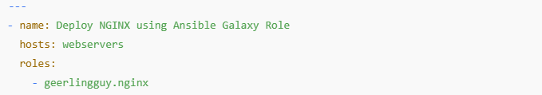

**In this playbook:**

* **hosts: webservers** defines the target hosts.
* **roles: - geerlingguy.nginx** specifies the Galaxy role.

Ansible will use this pre-defined role to handle **NGINX** installation and configuration.

By following these practices, your Ansible playbooks and roles become easier to maintain, reuse, and scale across environments, making your automation workflows much more robust and organized.